Lab – Ethical Hacking - Preparing Your Server 2016 Target

Overview

In this lab, you will learn how to prepare Server 2016 for promotion to a domain controller. The method demonstrated in this lab is the same method used in the real world to quickly get a domain controller up and running with as few steps as possible.

Requirements

One freshly installed virtual machine is running Server 2016 with GUI.

Log in to the machine locally as administrator.

Begin the lab!

Setting a static IP address

Click on the Server 2016 start button. Click on the Search icon (1); in the search box, type CMD for command prompt (2). From the results, select Command Prompt (3).

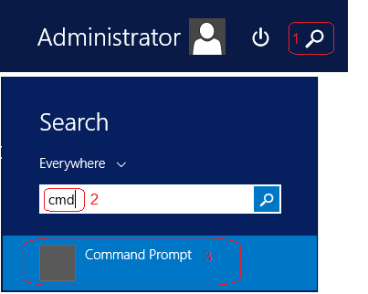

Once the command prompt opens, at the prompt, type IPCONFIG. Find your IPv4 address and either remember it or write it down. (You can leave the prompt open if you like)

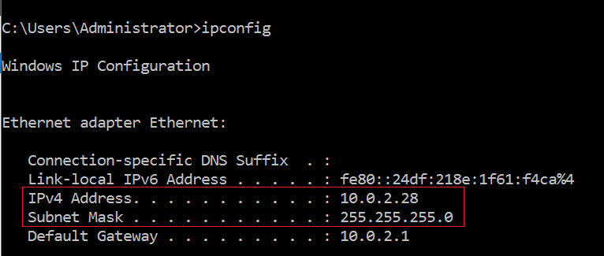

This is my IPv4 IP address! Your IP address will differ.

Inside of your Server Manager, in the right windowpane, find your Ethernet properties. Click on the blue link to access your network connections.

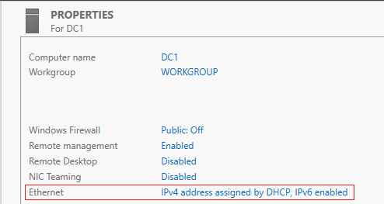

Under network connections, find your Ethernet adapter. This is the network adapter assigned to your Server 2016 virtual machine—Right-click on the adapter and select properties.

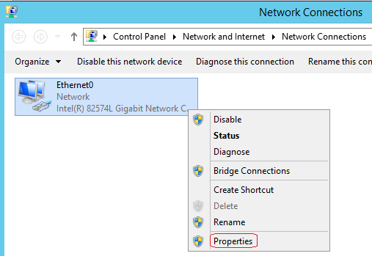

On the adapter’s properties page, from the listed items, select Internet Protocol Version 4 (TCP/IPv4) and either double-click the item or highlight and select the properties button.

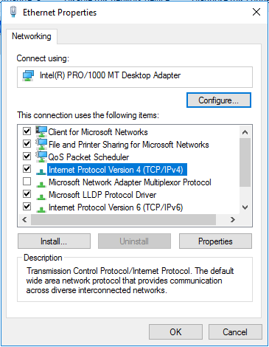

On the properties paid for your Internet protocol version 4, select the radio button for “Use the following IP address.”

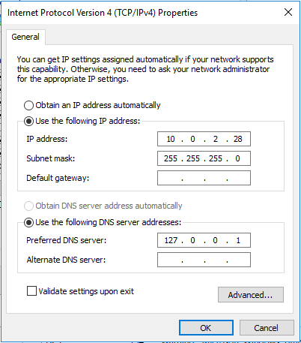

On the properties paid for your Internet protocol version 4, select the radio button for “Use the following IP address.”

In the IP address box, type the IPv4 address you discovered using the IPCONFIG command earlier in the lab.

On your keyboard, press the Tab key, and you will be brought down to the box for your subnet mask. Ensure the first four octets say, 255.255.255.0.

For your preferred DNS server address, since this machine will be hosting DNS, we do not want the machine to register with itself. We tell the machine to look locally for any DNS records by using the machine’s loopback address. In the preferred DNS block, type 127.0.0.1.

We could leave the preferred DNS block and empty, and when we install DNS, the loopback address will automatically be configured. Leaving the block empty generates a warning when DNS is installed, which may confuse those new to server 2016.

Testing for network connectivity

Once you have all the information correctly filled in for the TCP/IP version for properties, click on the okay button. The machine is now statically configured with an IP address.

To ping a Windows Server, you must either allow ICMP traffic to pass through the Server’s firewall or disable the firewall for private and public networks.

For this lab, we will disable the firewall.

Click on the Start button. Click the tile labeled Control panel.

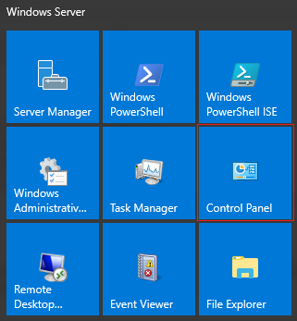

Inside the Control Panel, click on System and Security.

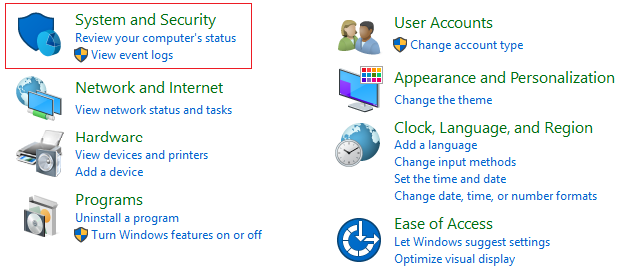

On the next screen, from the right windowpane select, Windows Firewall

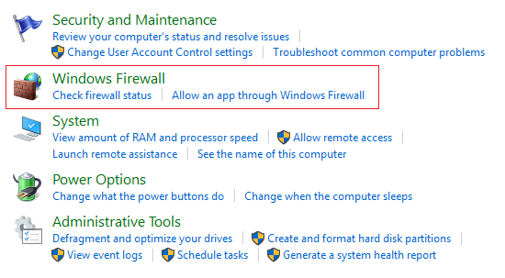

On the next screen, from the left windowpane, click where it says, Turn Windows Firewall on or Off.

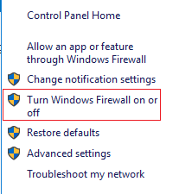

On the next screen, check the radio buttons that turn the Windows Firewall for private and public networks off.

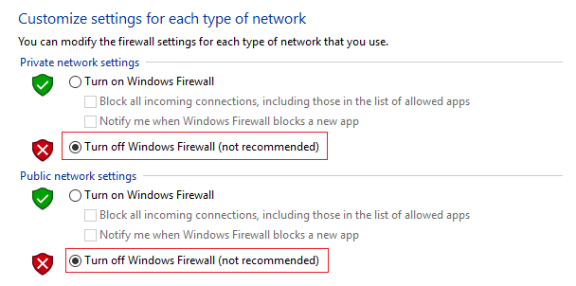

From your Kali machine, if your network adapters for VirtualBox are both set to NAT network, you should be able to ping from your Kali machine to your Server 2016 target to confirm your network connectivity.

Summary

Why We Statically Configure the IP Address

Machines and devices that need to be constantly available on the network need to be statically configured for IP addressing. These include domain, controllers, file servers, routers, switches, firewalls, and web servers, to name a few.

End of the lab!